ShreX: SharePoint end User Guide
Approval Workflow
August 2, 2022
Zensar Technologies LTD.

Contents
Start Approval Process 2
Approve/Reject Approval Request 3
Unpublish Document 4

Start Approval Process
- Click on ShareX:Publish option to start approval process on the document.
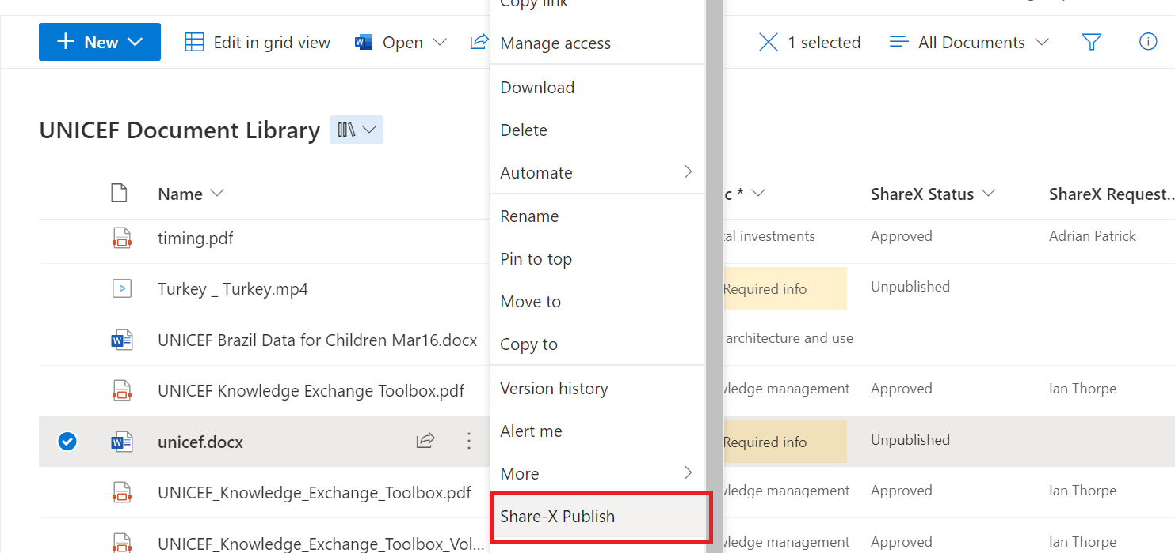
- Document status will be changed to In Progress once you start the approval process. Document will be locked from further editing.
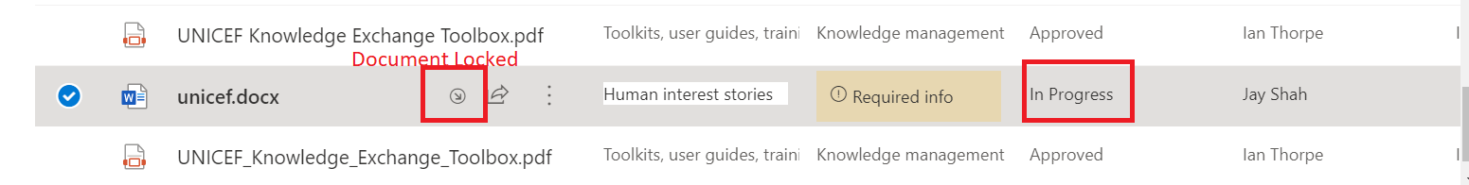
- Email will be triggered to Approver users (users of ShareX Approver Group) which contains link for the document as well as link for Approval Page

Approve/Reject Approval Request
- Below is the approval page. Approval user can approve/reject the request.
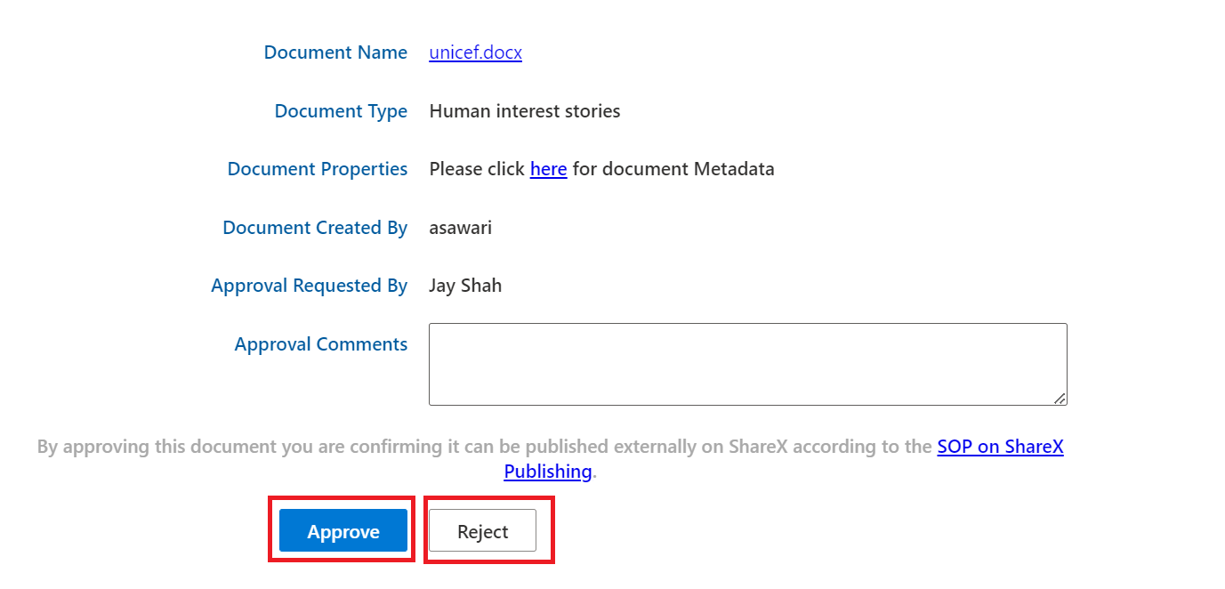
- If user approves the request, Document status will be changed to approved. Document will be locked until its unpublished.
- If user rejects the request, Document status will be changed to rejected. Document will be unlocked for further updates.
- Requester user will be notified on approve/reject of the document.

Unpublish Document

- Only approver users can unpublish the document.
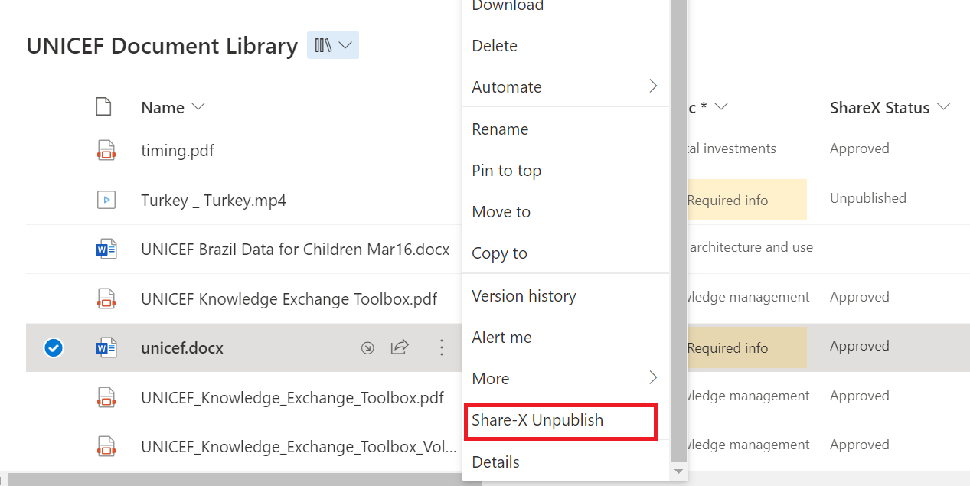
- Once the document is unpublished, status will be changed to unpublished and it will be unlocked for editing.
- Requester will be notified by email when the document is unpublished.

